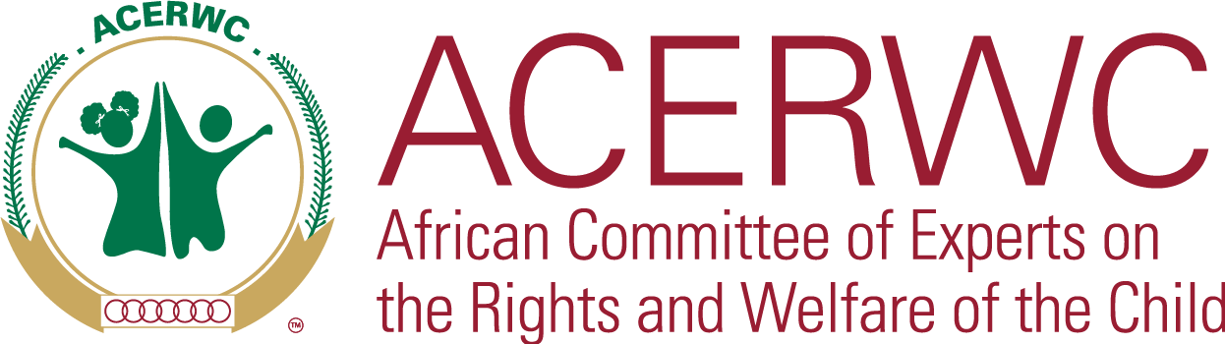

**ACERWC Secretariat**

**E-mail:** [acerwc-secretariat@africa-union.org](mailto:acerwc-secretariat@africa-union.org)

**Tel**: +266 52 01 00 18 **| P.O.Box:** 13460,

**Address:** Nala House, Balfour Road Maseru

Kingdom of Lesotho

**TERMS OF REFERENCE**

**AFRICAN COMMITTEE OF EXPERTS ON THE RIGHTS AND WELFARE**

**OF THE CHILD**

**APPOINTMENT OF EXTERNAL EXPERTS FOR THE WORKING GROUP ON THE IMPLEMENTATION OF DECISIONS**

**Appointment Period December 2025- November 2027**

|  |
| --- |
| **External Experts (4)** |
| **Key Task:** Serving in the Working Group of the ACERWC on Implementation of Decisions in the fulfilment of the mandate of the Group. |
| **Duty station**: Home-based with travels to attend meetings of Working Groups, on-site activities of the Working Group and Ordinary Sessions of the Committee. |
| **Contract type and duration**: Part-time external experts (4), for 2 years |
| **Date of appointment**: December 2025 |

1. **Background**

The African Committee of Experts on the Rights and Welfare of the Child (ACERWC) is an African Union Organ established to monitor the implementation of the African Charter on the Rights and Welfare of the Child (the Charter).As per Article 43 of the Charter, the ACERWC has the mandate to receive and consider State Party reports on the status of the implementation of the Children’s Charter. After considering State Party reports, it issues concluding observations and recommendations on the measures that States Parties may take to improve the implementation of the Charter. In accordance with Article 44, the ACERWC also has the mandate to consider communications/complaints against States Parties on alleged violations of the Charter, where the Committee also issues decisions as the case may be. Furthermore, the ACERWC may undertake investigations on child rights issues pursuant to Article 45 of the Charter, after which it issues recommendations and calls for action on the matters under investigation. The ACERWC also issues recommendations and calls for action to Member States of the African Union on children’s rights issues through letters of urgent appeals, resolutions, and statements, among others.

The ACERWC notes that its recommendations and decisions arising out of its mandate enhances the implementation of the Charter if they are implemented. Hence, monitoring States’ compliance with the decisions and recommendations of ACERWC is key to fully realising children’s rights on the continent as prescribed in the Charter. Through its various follow-up and monitoring mechanisms the ACERWC noted, based on evidence, that there is a gap in implementation of its decisions and recommendations.

To address the gaps in implementation, during its 35th Ordinary Session, held virtually from 31 August to 08 September 2020, the ACERWC established the Working Group on the Implementation of Decisions. The Working Group was primarily composed of four Members of the ACERWC and is mandated to undertake activities as defined by the Resolution establishing the Working Group and the Standard of Operating Procedures for the establishment of Working Groups as Special Mechanisms within the ACERWC. Furthermore the ACERWC during its 40th Ordinary Session of the ACERWC held from 23 November-01 December 2022 decided to broaden the scope of its Working Group on the Implementation of Decisions’ mandate to enable the Working Group to undertake follow up of the decisions of other organs of the African Union including the AU policy organs’ decisions pertaining to children’s rights.

Cognisant of the need for regular and continued monitoring of the level of implementation towards achieving the full implementation of its recommendations and decisions, also, mindful of the role that external experts could play in enhancing the work of the Working Group, the Committee during its 43rd Ordinary Session held from 15 to 25 April 2024 decided to expand its composition to include individuals who will be serving as Members of the Working Groups in their capacities as ‘experts on the field’.

In this regard, and acknowledging the crucial role of external experts as members of the Working Group, their services are sought to assist the undertakings of the Working Group, support the implementation of its activities and contribute to the fulfilment of its mandate. The Working Group will undertake its activities guided primarily by the African Children’s Charter, the Resolution establishing the Working Group, and the Standard of Operating Procedures for the establishment of the Working Groups as Special Mechanisms within the ACERWC.

1. **Main duties and responsibilities of external expert**

The external experts support the Working Group in discharging its mandates, as per the Decision of the Chair of the Working Group and as contained in the Resolution for its establishment and reiterated as follows;

1. Support the Activities of the Working Group in disseminating the findings and recommendations of the ACERWC’s study on the Implementation of Decisions;
2. Provide expertise and draft documents, standards, guidelines, and policy briefs as decided by the Working Group and approved by the Committee;
3. Provide technical expertise to support the Working Group as external experts in the exercise of their respective responsibilities/mandates as stated in these ToRs;
4. Assist the Working Group in regularly collecting information from Civil Society actors and National Human Rights Institutions, on their assessment of the level of implementation of the Committee’s Decisions and recommendations.
5. Provide support to the Working Group in assessing the level of implementation of the ACERWC's decisions and recommendations by concerned States Parties, and in producing relevant reports.

1. **Qualifications**
2. Advanced university degree in law, International Law, Human rights, children’s rights, or other related disciplines;
3. A minimum of 10 years of working experience in the area of children’s rights or general human rights in the African context;
4. National of an African country;
5. Demonstrated knowledge, experience and understanding of the African Children’s Charter as well as the ACERWC;
6. Demonstrated knowledge of the practice, procedure, and jurisprudence of the African human rights system;
7. First-hand knowledge and experience of the cultural, social, economic and political context of Africa;
8. Fluency in one of the AU Languages, is required, and knowledge of additional African union working languages is desirable;
9. Work experience in the AU, UN, and other international organisations is desirable;
10. Excellent analytical skills using both qualitative and quantitative methods.
11. **Reporting lines**

The external experts will work under the supervision and guidance of the ACERWC and the Chair of the Working Group on Implementation of Decisions.

1. **Duration and Attendance**

The appointment of successful candidates will commence immediately from the date that the Committee finalises and adopts the selection, which will run through November 2027. The external experts will be required to attend all the meetings of the Working Group and selected activities of the Working Group; s/he will also be required to attend relevant Ordinary Session of the Committee upon request of the Chairperson of the Working Group.

1. **Location**

The appointment will be home-based with the above-mentioned travels to attend working group meetings and the ACERWC sessions whenever necessary.

1. **Reimbursement**

The external experts shall not be considered employees; as such, they are not entitled to any form of remuneration. However, the full travel costs of the external experts will be covered, and a daily subsistence allowance will be given for the duration of travels based on African Union rules and regulations.

1. **Application**

The application document should consist of the following:

1. A cover letter summarising the background of the applicant and why the applicant is interested in the position;
2. A Customised Curriculum Vitae not exceeding 3 pages;
3. Evidence of educational background and professional experience;
4. Samples of publications, professional undertakings or related activities which demonstrate the applicants’ expertise in the areas of state compliance and implementation of decisions and recommendations; and
5. Names and contacts of three references.
6. **Application deadline**

The application should be submitted to the Secretariat of the ACERWC no later than 20 October 2025. Applications should be sent to [opportunities-acerwc@africanunion.org](mailto:opportunities-acerwc@africanunion.org) copying [mahjouba@africanunion.org](mailto:mahjouba@africanunion.org).